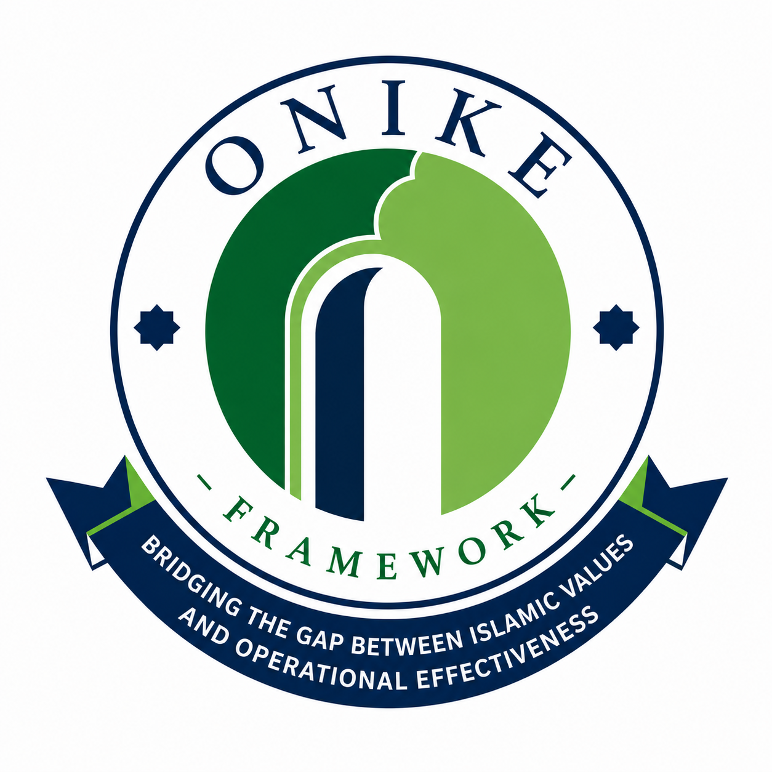 THE ONIKE FRAMEWORK™  International Collaboration Prospectus  Advancing Strategic Growth, Operational Excellence, Sustainability, Ethical Finance and Human Development in Islamic Institutions | 

PAGE 1 · WHO WE ARE
Transforming Islamic Institutions Through Research, Innovation and Excellence
The Onike Framework™ is a research-driven ecosystem of integrated frameworks developed to strengthen Islamic institutions through strategic growth, governance, operational excellence, sustainability, ethical finance, leadership development, artificial intelligence, and Maqāṣid al-Sharī'ah.
Designed for universities, Islamic financial institutions, NGOs, waqf organisations, zakat agencies, educational institutions, humanitarian organisations and governments, the framework combines contemporary management science with Islamic principles to provide practical assessment, benchmarking and continuous improvement tools.
Unlike conventional excellence models that address isolated organisational functions, the Onike Framework™ provides an integrated ecosystem covering institutions, leaders and individuals.
The Framework Ecosystem
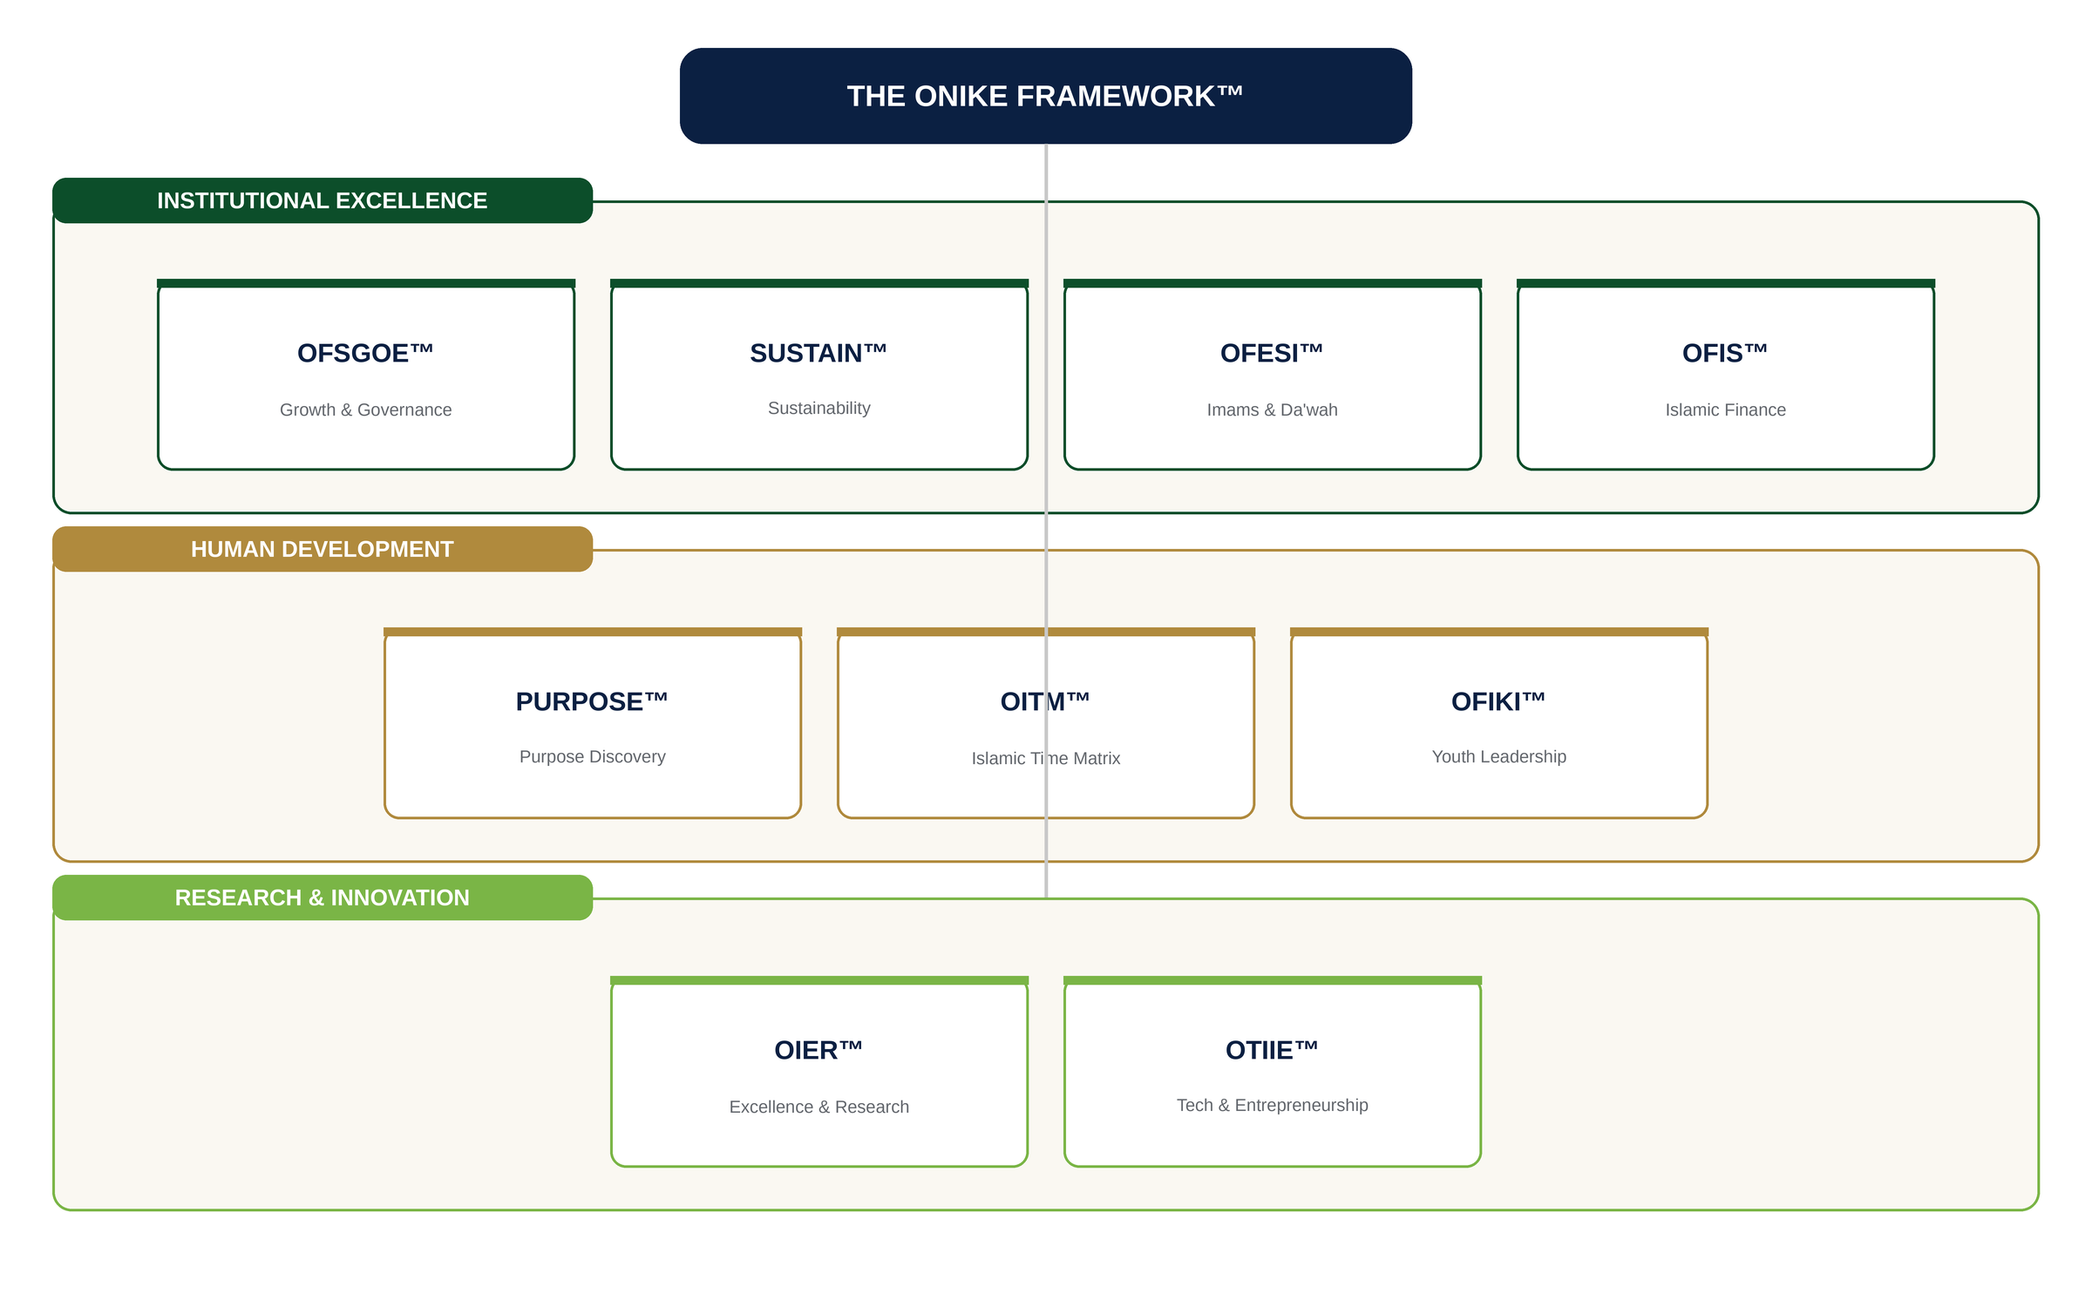
Distinctive Features
✓ Evidence-based methodologies | ✓ AI-assisted diagnostics and coaching
✓ Digital assessment platform | ✓ Institutional maturity assessment
✓ Automated reporting | ✓ Professional certification
✓ International benchmarking | ✓ Research-ready architecture
✓ Multilingual platform

PAGE 2 · FRAMEWORK PORTFOLIO
Current Development Status
From advanced conceptual frameworks with live pilot data to emerging research streams, each model in the ecosystem progresses through a disciplined research-to-deployment pathway.
  OFSGOE™
  STATUS
  Advanced conceptual framework supported by multidisciplinary research, with pilot exercises conducted on four Islamic institutions.
  OFESI™
  STATUS
  Online assessment platform with automated scoring, AI-assisted recommendations and digital maturity reports — piloted with NASFAT Imams.
  SUSTAIN™
  STATUS
  Institutional and individual sustainability assessment framework — currently in research and implementation phase.
  PURPOSE™ (OPDF)
  STATUS
  Purpose Discovery Framework supporting leadership readiness, career alignment and personal development — prototype and research development.
  OITM™
  STATUS
  Islamic Time Matrix integrating productivity diagnostics, time stewardship and AI-assisted coaching — advanced conceptual development.
  OFIKI™, OIER™, OTIIE™, OFIS™
  STATUS
  Knowledge integration for youth, research excellence, innovation and Islamic finance sustainability — conceptual and emerging development.
The Digital Assessment Ecosystem
Live screens from the onikeframework.org digital platform, where institutions complete assessments, receive AI-assisted maturity scores, and verify credentials through a public certification registry.
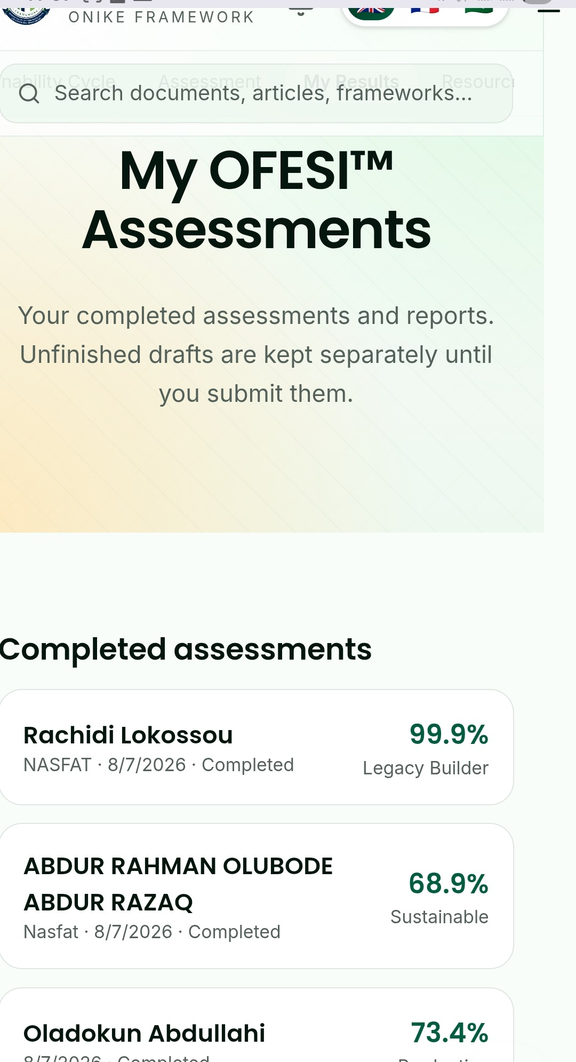  OFESI™ Digital Assessment Portal | 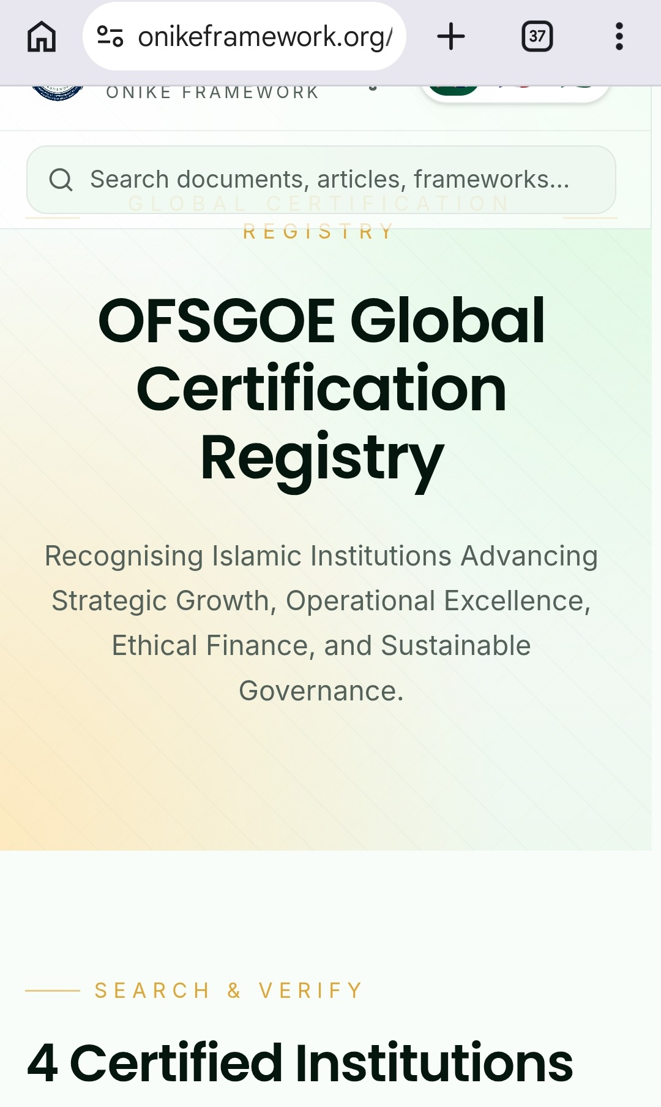  Digital Certification & Verification Registry

PAGE 3 · IMPLEMENTATION ROADMAP & PILOT OPPORTUNITIES
From Engagement to Impact
A nine-stage pathway carries every partner institution from first engagement to measurable, certified impact.
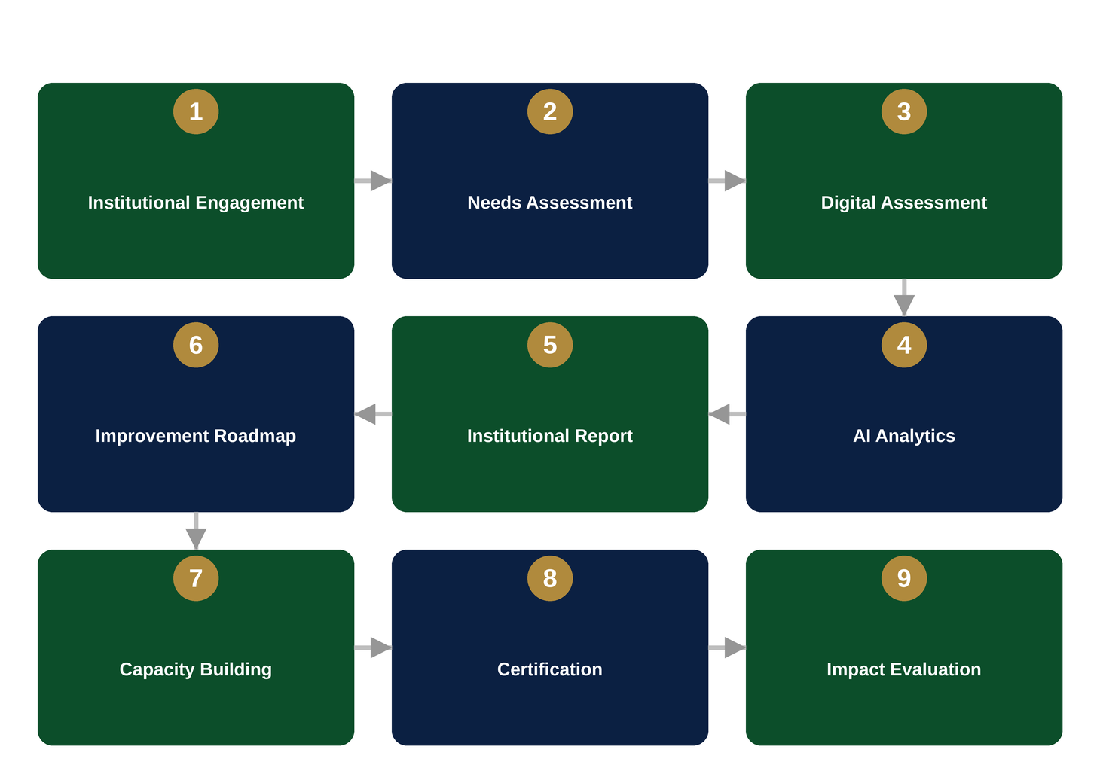
Governance Model  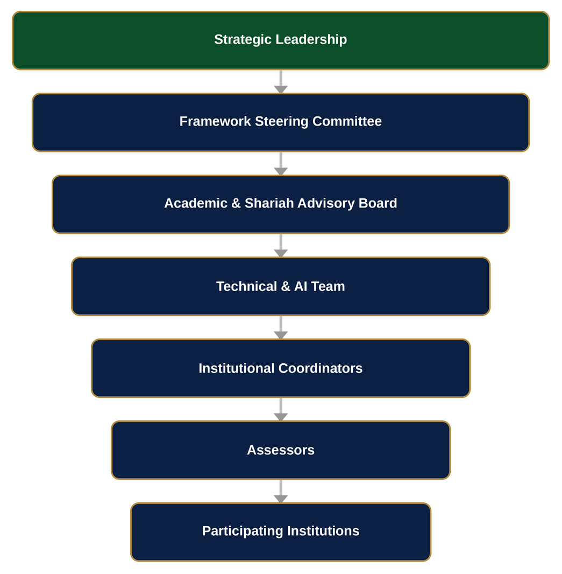 | Pilot Opportunities  ✓ Institutional assessments  ✓ Executive leadership programmes  ✓ AI-assisted coaching  ✓ Organisational benchmarking  ✓ Framework validation  ✓ Cross-country comparative studies  ✓ Capacity building & certification  ✓ Joint conferences & co-authored publications
Early Case Studies
NASFAT
Pilot implementation of OFESI™ involving Imams and Missioners to assess effectiveness and sustainability across a global network of 350+ locations.

Four Islamic Institutions
OFSGOE™ pilot exercises conducted to evaluate strategic growth, governance and operational excellence.

Ongoing Research Development
Research expansion continues through postgraduate studies, conference presentations and peer-reviewed publications.

PAGE 4 · COLLABORATION OPPORTUNITIES
Ways to Partner With Us

  Research
  • Joint research
  • Co-authored publications
  • Research grants
  • Conference collaborations
  Pilot Implementation
  • Institution-wide assessment using one or more Onike Framework™ models
  Capacity Building
  • Strategic growth & governance
  • Sustainability & leadership
  • Operational excellence
  • Ethical finance & AI readiness
  Technology Collaboration
  • AI-assisted diagnostics
  • Benchmarking dashboards
  • Digital reporting
  • Multilingual assessments
  International Benchmarking
  • Comparative assessment of Islamic institutions using standardised maturity models
  Policy & Advisory
  • Institutional standards
  • Governance frameworks
  • Sustainability indicators
  • Policy papers
Why Collaborate?
A partnership with the Onike Framework™ enables organisations to:
✓ Strengthen institutional effectiveness | ✓ Enhance governance and accountability
✓ Improve sustainability and resilience | ✓ Advance Maqāṣid al-Sharī'ah implementation
✓ Promote ethical finance and operational excellence | ✓ Build AI-enabled institutional capability
✓ Benchmark against international best practices | ✓ Generate evidence-based research and measurable impact

Vision Statement
Transforming Islamic Institutions through Strategy, Sustainability, Operational Excellence, Ethical Finance, Innovation and Purpose-Driven Leadership.
Imam Abdul-Azeez Onike Morufu
Developer, The Onike Framework™
info@onikeframework.org · onikeazeez@gmail.com
+234 803 304 7894 · +234 907 888 8882
https://onikeframework.org

